ORDER FORM

Male Ensemble Northwest CD’s

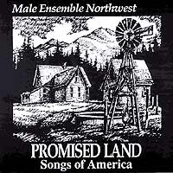
PROMISED LAND: Out of print
Songs Of America
MEN’s first CD is filled with a variety of songs from Americana. Included on this recording are: Promised Land, Be Thou My Vision, O Thou In Whose Presence, Rise Up O Men Of God, We Shall Walk Through The Valley In Peace, The Gift To Be Simple, Somebody’s Calling My Name, Ezekiel Saw The Wheel, Joshua, I Can’t Tarry, Streets Of Laredo, Colorado Trail, Down In The Valley, Shenandoah, Blow The Candles Out, Mary Ann, A-Roving, Lonesome Road, and Televsion Medley.

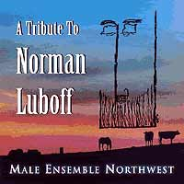
A Tribute To Norman Luboff
This album is dedicated to composer, publisher, and arranger, Norman Luboff. Luboff made a name for himself in the 60’s and 70’s with the lush sound of his touring choir. This album features ethnic, jazz, and a number of western songs. Included on this recording are: Dream A Little Dream, But Beautiful, Since You Went Away, Yellow Bird, Valencianita, Carmen Carmella, Aupres De Ma Blonde, A-Rovin, Rio Grande, Lowlands, The Old Chisholm Trail, Colorado Trail, Doney Gal, Whoopie Ti Yi Yo, Cool Water, Streets Of Laredo, Tender Love, Red River Valley.

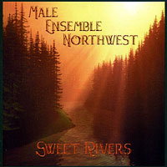
Sweet Rivers
This album, recorded in 2007 is mostly a collections of songs either written by MEN members, or songs written especially for the ensemble by others. This album includes a wide variety of genres, from the Celtic Songs of Vijay Singh, all the way to arrangements of tunes by the Beatles. Selections include: Timor Et Tremor, Shout for Joy, Alleluia, Sweet Rivers, When I Hear The Trumpet Sound, A City Called Heaven, Fergus and Mollie, Lament of a Fisher's Wife, Finnan Haddie, Soon and Very Soon, I Will, Eleanor Rigby, and Irish Blessing.

Item Qty. Total
1.Promised Land _______x $15.00 $________

2. A Tribute To Norman Luboff _______ x $15.00 $________
3. Sweet Rivers _______x $15.00 $________
4. On That Shore _______x $15.00 $________
Shipping 1 CD $3.00
2-4 $4.00
5-10 $5.00
10-20 $6.00 $_______

Total: $________

Send to: Male Ensemble Northwest
1600 12th St. SW, Puyallup, WA 98371

Please make checks payable to “Male Ensemble Northwest”

Shipping Address: ___________________________________________________________

___________________________________________________________

___________________________________________________________

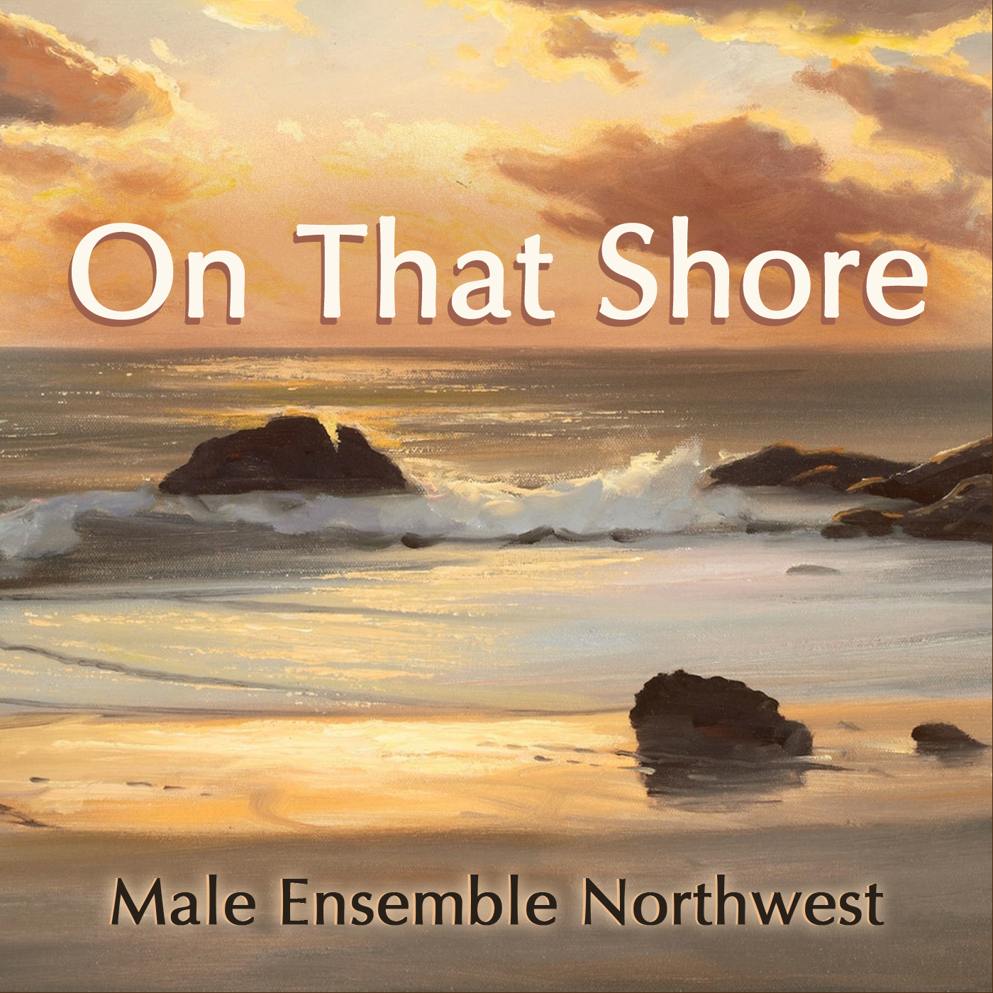On That Shore
is our newest release.
Selections are: O Sing To The Lord, Tu Es Petrus, Ute Sundance,
Wana Baraka, In The Sweet By and By, Hold On, El Paisanito, Khorumi, When I Hear Her I Have Wings, Hard Times Come Again No More, Somewhere Over The Rainbow, All of Me, The Steady Light.

Four of the pieces were either written or arranged by members of MEN. The songs are all from our concert sets over the last 3 years.

